Directions to:
Jamaica’s Honorary Consul
50 Ickneild Street, Hockley, Birmingham B18 5AY
Telephone: +44 (0)121 551 2772

1. By car
Birmingham is well sign-posted and surrounded by motorways; the M1, M40, M42, the M5, and the M6 which includes the infamous Spaghetti Junction (Gravelly Hill Interchange). Once in the West Midlands:
- Approaching from the north west or south east along the M6 - Junction 6 take the A38(M)/A38 exit to Birmingham (E & Central) Birmingham (NE/Lichfield)
Keep right at the fork, follow signs for A38(M) and merge onto A38(M.
Take the exit toward Ring Road
Merge onto Aston Rd/A5127
At the roundabout, take the 3rd exit onto Newtown Middleway /A4540
Continue to follow A4540
Go through 1 roundabout
At the Hockley Circus Flyover roundabout, take the 3rd exit Heaton
Street
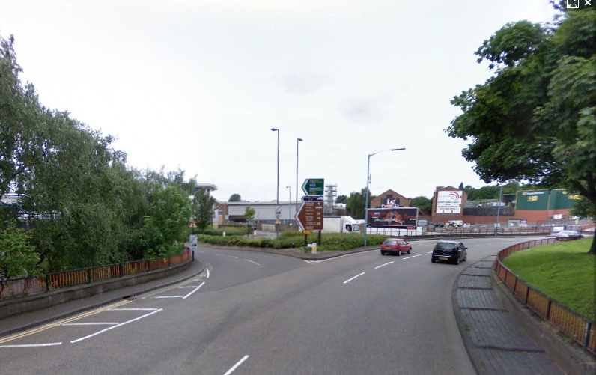

and then sharp left, Signposted “Icknield Street No’s 1-50”
Destination will be at the end of the road on the left.
- Approaching from the M42 north:
Leave at Junction 8 to join the M6 northbound and follow the instructions above.

- Approaching from the M5 from the south west:
Leave Junction 1, take the A41 exit to West Bromwich/Birmingham (NW).
At the roundabout, take the 5th exit onto Birmingham Rd/A41.
Continue to follow A41 – keep left to continue onto Soho Hill/A41.
At Hockley Flyover, keep left, down to the roundabout then take 5th exit onto Heaton Street.

Then sharp left, sign-posted “Icknield Street No’s 1-50”; destination is at the end of the road on the left.

- Approaching from the M40:
M42, M6 Birmingham Central follow the instructions number 1 above.

2. By Public Transportation
Bus, Train and Metro all come under the authority of Network West Midlands (Part of Centro, the PTE of Birmingham and surrounding area), their website is the best source for all information required on public transport in the region [8].
Company name: National Express West Midlands
Contact number: 0121 460 8764
Website address: www.nxbus.co.uk

3. Travelling by air
Birmingham International Airport has direct flights from locations in the UK, as well as from the USA, Canada, Europe and the Middle East.
The journey by taxi from the airport to the Cleone Foods takes approximately 30-45minutes. Alternatively, Air-Rail Link provides a free, fast connection between the airport terminals and Birmingham International railway station. Air-Rail Link operates every two minutes (journey time 90 seconds). Birmingham International railway station has frequent services to New Street Station in the city centre (journey time around 15 minutes).
If you are arriving at London, there is a frequent train service from London Euston railway station to New Street Station (journey time around 1 hour 30 minutes).
From Heathrow Airport - Take the Heathrow Express train to Paddington Station and then the Underground or a taxi to Euston Station. Alternatively, an Airbus runs from Heathrow Airport direct to Euston Station From Gatwick Airport. Take the Airport Express train to Victoria Station and then the Underground or a taxi to Euston Station.

4. Travelling by Bus
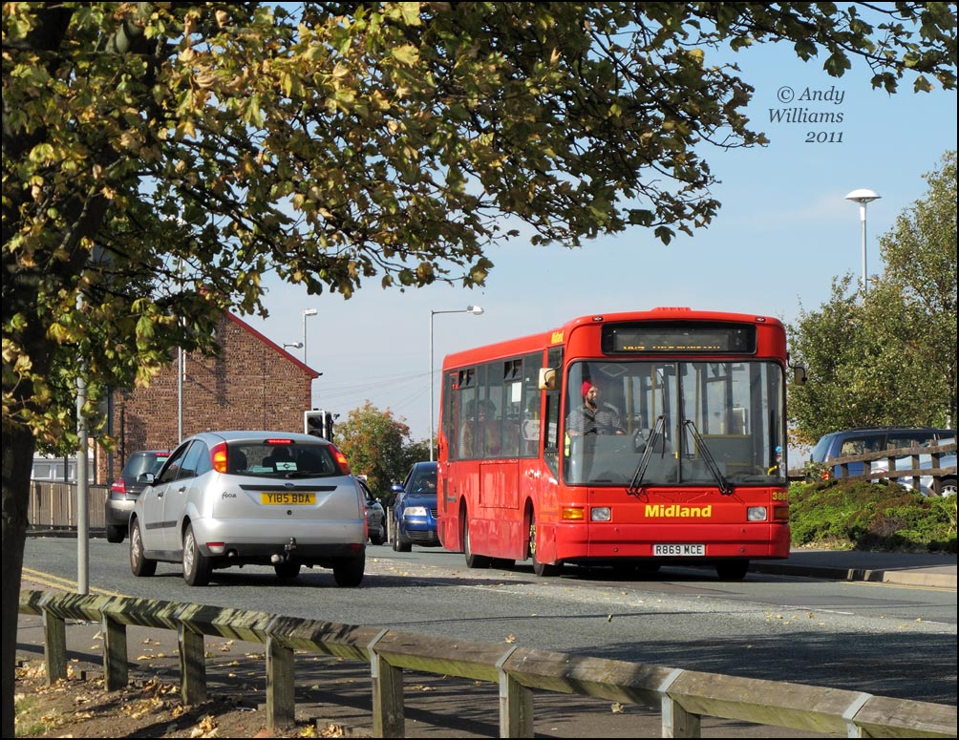
Numbers 16, 74,75 and 79.
There is a travel information office outside New Street Station, where you can obtain bus timetables and departure point information. Maps can be found throughout the city centre indicating bus stop locations.
5. Travelling by Coach
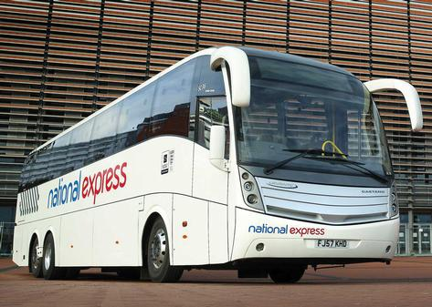
There are frequent express coach services to Birmingham from London, Heathrow and Gatwick Airports, and many UK cities. The long-distance coach station is in Digbeth in the city centre
Digbeth Coach Station is a short walk from New Street train Station. Taxis are available outside the station and take about 15mins to Cleone Foods.
6. Travelling by Rail
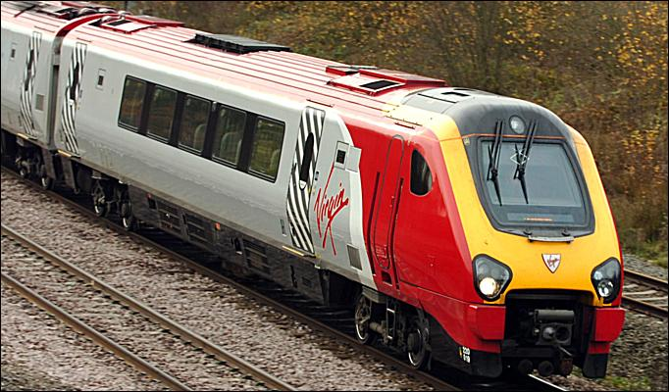
Wikitravel has a guide to Rail travel in the United Kingdom
Birmingham is a major hub of Britain's rail network. The main station is New Street, with Snow Hill and Moor Street carrying significantly fewer services, but include superior service from London Marylebone station. New Street also has faster, but more expensive, services to London Euston. New Street and Moor Street are a 5 minute walk apart, and Snow Hill is around 10 minutes walk from each.
Allow plenty of time to find your train at New Street station as it is huge and very confusing, and as it is currently undergoing modernisation the layout is constantly changing. Most platforms (tracks) are divided into sections (e.g. Platform 4A, 4B and 4C) and it's not uncommon for two trains bound for different destinations to depart from the same track, so make sure you wait in the right area and board the right train! New Street Station is notorious for last-minute platform changes so it's advisable to wait close to the stairs and keep close attention to the information screens and PA announcements as you may need to make a quick dash to the opposite side of the station with only 3 minutes until departure!
Timetables can be checked at National Rail Enquiries [4] (0845 748 49 50) and booked on-line or over the phone through the train operator.
7. Travelling by Taxi
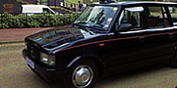

There are taxi ranks at New Street, Moor Street and Snow Hill Stationsand throughout the city centre. The journey to the Cleone Foods takes about ten/15 minutes.

Map

